Module 2: Baseline Assessment

Session 4: Livelihood Zoning

Handout 1 - Exercise on Livelihood Zones

Exercise 1

Below is a map showing the agro-climatic zones and farming regions of Zimbabwe.

Agro-climatic/farming map of Zimbabwe
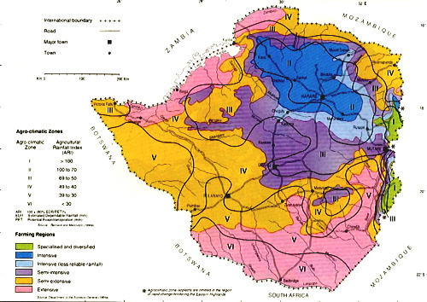
Farming Regions
Specialized and diversified
Intensive
Intensive (less reliable rainfall)
Semi-intensive
Semi-extensive
Extensive

“Vincent and Thomas (1960) divided Zimbabwe into five main natural regions according to differences in effective rainfall. Rainfall patterns and crop production progressively deteriorate from Region I to V.”
Vincent, V. and Thomas, R.G. 1960. An agricultural survey of Southern Rhodesia: Part I: agro-ecological survey. Government Printer, Salisbury
Source: www.fas.usda.gov

Write down how you think this map is different from a livelihood zone map. What elements of a livelihood zone map are missing?

Exercise 2

You are conducting a baseline assessment in one livelihood zone and you find that:

- Although you are assessing an agricultural livelihood zone, you arrive in a selected village to find that there is a nearby lake and households are almost entirely dependent on fishing for their cash income. Should you carry on with the fieldwork for your baseline assessment in that village?

- The four selected villages in the northern half of the livelihood zone are currently experiencing a drought, while those in the southern half are not. Should the livelihood zone be split in two for the baseline analysis?

- The western half of the livelihood zone has good access to clean water and health care because of an NGO programme in the area, while villages in the eastern half of the livelihood zone have very poor access. Should the livelihood zone be split in two for the baseline analysis?

